TOWNSHIP OF OXFORD
11 Green Street www.oxfordtwpnj.org Phone: 908-453-3098
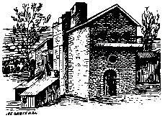
Oxford, NJ 07863 Fax: 908-453-3787

THE CLERKS OFFICE

WILL BE CLOSED ON

FRIDAY JUNE 13, 2025

THE OFFICE WILL RE OPEN ON

MONDAY JUNE 16, 2025

HAVE A GREAT WEEKEND

